PROJECT REPORT OF CO-OP Project at Industry
ON
Mental Health and its Impact on Public Productivity
submitted in partial fulfilment of the requirements for the award of degree of

BACHELOR OF ENGINEERING
In
COMPUTER SCIENCE AND ENGINEERING

Submitted by: Supervised By:
Goransh Handa (2210990329) Gurpreet Singh
Khushi Bansal (2210990510)
Aryan Sharma (2210990179)


DEPARTMENT OF COMPUTER SCIENCE AND ENGINEERING

CHITKARA UNIVERSITY INSTITUTE OF ENGINEERING AND TECHNOLOGY
CHITKARA UNIVERSITY, PUNJAB, INDIA

CONTENTS

S.No. | Title | Page No.
 | Acknowledgement | iv
 | List of Figures and Tables | v
 | Abstract
1 | Introduction | 1
2 | Methodology
3 | Tools and Technologies
4 | Implementation
5 | Major Findings/Outcomes/Output/Results
6 | Conclusion and Future Scope
 | References
 | Appendices

DECLARATION

I hereby certify that the work which is being presented in the project report entitled “Title of the Project” in partial fulfilment of requirement for the award of the degree of Bachelor of Engineering (Computer Science and Engineering) submitted in the department of Computer Science and Engineering at Chitkara University Institute of Engineering and Technology, Chitkara University, Punjab, India, is an authentic record of my own work carried out under the supervision of <Name of the Mentor>. The matter presented in this project report has not been submitted in any other university/institute for the award of any degree.

Place: Rajpura Khushi Bansal, Goransh Handa , Aryan Sharma
Date: 29 – 04 - 2026 2210990510 , 2210990329 , 2210990179

This is to certify that the above statement made by the candidate is correct to the best of my knowledge and belief.

Dr. Gurpreet Singh
Department of Computer Science and Engineering
Chitkara University Institute of Engineering and Technology,
Chitkara University, Punjab, India

ACKNOWLEDGEMENT

I would like to express my sincere gratitude to everyone who supported me throughout the completion of this project.

Firstly, I am deeply thankful to my project guide for their valuable guidance, encouragement, and continuous support at every stage of this work. Their insights and suggestions greatly helped in shaping this project.

I also extend my gratitude to the faculty members of my department for providing me with the necessary knowledge and resources required for the successful completion of this project.

I would like to thank my friends and classmates for their cooperation, motivation, and helpful discussions, which contributed significantly to this work.

Lastly, I am grateful to my mentor for their constant support, encouragement, and understanding throughout this project.

Abstract

Mental health has become a critical aspect of overall well-being in today’s fast-paced and demanding environment. Increasing levels of stress, anxiety, depression, and irregular sleep patterns significantly impact an individual’s productivity, decision-making ability, and quality of life. This project presents the development of a Mental Health Detector System, designed to analyze key psychological parameters and provide a visual and analytical representation of an individual’s mental state.
The system collects user inputs based on various mental health indicators such as stress level, anxiety level, depression level, and sleep quality using a standardized rating scale. These inputs are then processed using computational techniques to generate graphical outputs, including line graphs and pie charts, enabling users to easily understand their mental health condition.
This project is supported by an in-depth research study that highlights the relationship between mental health factors and productivity. The research emphasizes how prolonged stress and poor mental health can lead to burnout, reduced efficiency, and cognitive decline, while positive habits and monitoring tools can improve overall well-being.
The proposed system aims to promote awareness, early detection, and self-assessment of mental health conditions through an easy-to-use interface. By integrating data visualization and research-backed insights, the project contributes to encouraging proactive mental health management and fostering healthier lifestyles.

Introduction

Mental health plays a vital role in determining an individual’s overall well-being, productivity, and quality of life. In recent years, factors such as academic pressure, work stress, social expectations, and lifestyle changes have significantly increased mental health concerns like stress, anxiety, depression, and sleep disorders.
Traditional mental health assessment methods often require professional consultation, which may not always be accessible or immediate. This creates a need for simple, self-assessment tools that can help individuals understand their mental condition at an early stage.
The Mental Health Detector System is designed as a user-friendly solution that allows individuals to input key mental health parameters and receive a visual representation of their condition. The project is supported by a research study that establishes a strong relationship between mental health factors and productivity levels. By combining user input, basic data analysis, and graphical visualization, this system aims to promote awareness and encourage proactive mental health management.

2. Methodology
The methodology of the project follows a structured approach:

- Data Collection: Users provide input on mental health parameters such as stress, anxiety depression, and sleep quality on a scale (e.g., 0–10).

- Data Processing: The system processes the input values and categorizes the mental health condition based on predefined thresholds.

- Analysis: The collected data is analyzed to understand the overall mental health status and identify dominant factors affecting the individual.

- Visualization: Graphical representations such as line graphs and pie charts are generated to present the data in an easy-to-understand format.

- Research Integration: Findings from the research paper are used to interpret results and correlate mental health parameters with productivity and well-being.

Tools And technologies
The development of the Mental Health Detector System utilized modern web technologies to create an interactive and user-friendly application.

- Frontend Development: React.js – for building a dynamic and responsive user interface
- JavaScript (ES6+) – for logic implementation and data handling
- HTML5 & CSS3 – for structuring and styling the application
- Data Visualization: Charting Libraries (e.g., Chart.js / Recharts) – for generating line graphs and pie charts to visually represent mental health parameters
- Development Tools: Visual Studio Code (VS Code) – code editor for development
Node.js & npm – for managing dependencies and running the React application
- Version Control (optional but recommended):
- Git & GitHub – for source code management and collaboration
- Platform:
Web-based application accessible through modern browsers
Documentation Tools:
MS Word / Google Docs – for report writing
MS PowerPoint – for project presentation
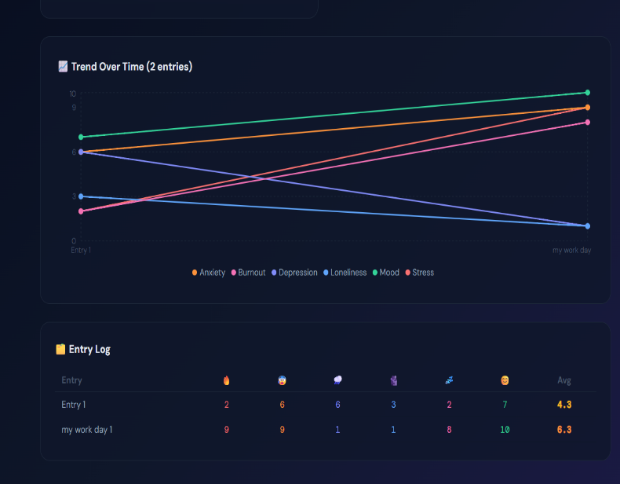
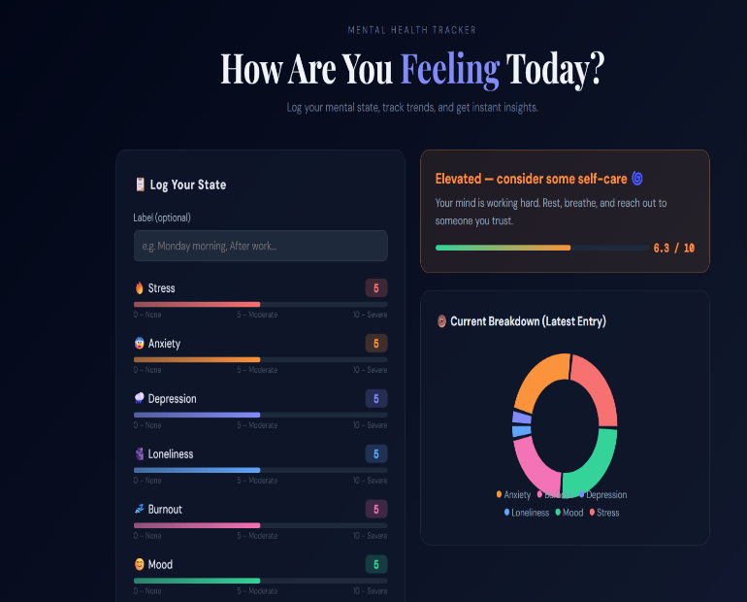

Implementation
The system is implemented using Python, where a simple interface is created to take user inputs for different mental health parameters.

The user is prompted to enter values for stress, anxiety, depression, and sleep quality.
These values are stored in variables and processed.

A line graph is generated to show variations across different parameters.

A pie chart is created to show the proportion of each factor affecting mental health.

Based on the input values, the system may also provide basic interpretations (e.g., high stress or low sleep quality).

The implementation focuses on simplicity, making the system easy to use even for non-technical users.

Major Findings / Outcomes / Results

The project led to several key observations:
- High levels of stress and anxiety are directly associated with poor mental well-being.
- Sleep quality plays a crucial role in maintaining mental stability and productivity.
- Visual representation of data helps users better understand their mental condition.
- Users become more aware of their mental health when they see quantified results.
- The integration of research findings validates the relationship between mental health and productivity.

The output of the system includes:
- Graphical analysis (line graph and pie chart)
- Basic mental health insights based on user input

Conclusion and Future Scope

Conclusion:
The Mental Health Detector System successfully demonstrates a simple yet effective way to assess and visualize mental health conditions. By combining user input with graphical analysis and research-based insights, the project helps in increasing awareness and encouraging early self-assessment.
It highlights the importance of monitoring mental health parameters and shows how even basic tools can contribute to better understanding and management of mental well-being.

Future Scope:
The project can be further enhanced in several ways:
- Development of a web or mobile application for wider accessibility
- Integration of AI/ML models for more accurate predictions
- Addition of more parameters such as mood tracking, lifestyle habits, and physical activity
- Real-time data tracking and history analysis
- Providing personalized suggestions and mental health recommendations
- Integration with wearable devices for automated data collection

References

- Research Paper Used in Project:
“Impact of Mental Health on Productivity and Well-being”
(Include full author names, journal/conference name, and year as per your actual paper)
- World Health Organization (WHO)
Mental Health Resources and Guidelines
https://www.who.int/health-topics/mental-health
- React.js Documentation
https://react.dev/
- Node.js Documentation
https://nodejs.org/
- Chart.js / Recharts Documentation
https://www.chartjs.org/
https://recharts.org/
- Visual Studio Code Documentation
https://code.visualstudio.com/
- Articles and online journals on:
  - Stress, anxiety, and depression analysis
  - Sleep and productivity relationship
  - Digital mental health tools and self-assessment systems

Appendices

Appendix A: Source Code
- React component files (e.g., mental-health-tracker.jsx)
- Input handling logic for mental health parameters
- Graph implementation using Chart.js/Recharts

Appendix B: User Interface Screens
- Input form where users enter:
  - Stress level
  - Anxiety level
  - Depression level
  - Sleep quality
- Output screen displaying results

Appendix C: Graphical Outputs
- Line Graph: Showing variation across mental health parameters
- Pie Chart: Showing contribution of each factor

Appendix D: Sample Inputs and Outputs
- Example:
  - Stress: 8
  - Anxiety: 7
  - Depression: 6
  - Sleep: 4
- Corresponding graphs and interpretation

Appendix E: Research Paper Summary
- Key findings from your research paper
- Relationship between mental health and productivity
- How your project is based on and supports the research

